Project Documentation: Berkay Topal
Deliverable 1
Project Idea: Brick Breaker / Arcade Game
Title of Game: Brick Blitz

Brief Justification of Project Idea:
- Brick breaker is a game that everyone overlooks on how easy it is, but the mechanics behind it, I believe, is very complex, and has a lot of room for scalability.
  - Hence want to prove that it is by making the game

- The idea offers good balance of challenge and feasibility, where it is a project that I can finish comfortably by the due date.

- It is an idea easily scalable, where I can keep adding more ideas to it as I go on. It is not limited to a certain point.

- Finally, it offers the understanding of complex topics such as collision detection and physics-based movement, further expanding my knowledge.

Problem Definition:
- Problem: Many arcade-style games provide quick, engaging gameplay, but lack the modern implementations that improve the user experience, and the ability for students & developers to learn complex and simple gameplay mechanics

- Idea: Hence, with Brick Blitz I plan to develop a fun, interactive Brick Breaker game that challenges players’ reflexes, allows students and developers to learn simple and complex gameplay mechanics, and overall provide a rewarding experience

Target Audience:
- Casual gamers who enjoy classic arcade-style games

- Students and developers interested in learning about game development, particularly collision detection, physics-based movement, and event handling in Pygame

- Game controls are simple and easy, so users of all ages allowed to play, but mainly targeting younger generation who more commonly play games

Objectives:
Main Objective:
- Develop a fully playable Brick Breaker game, with core mechanics (E.g. Ball movement, paddle control, brick-breaking, etc.), and side mechanics (E.g. Menu, Sound, Directional Control, Levels, etc.) that is better than Arkanoid.

Sub-Objectives:
- Implement collision detection between ball, paddle, bricks

- Design progressive difficulty, where it has multiple levels with increasing challenges

- Make power-ups & other mechanics to enhance gameplay

- Ensure smooth performance, efficient use of memory, and user-friendly control

- Make clear and aesthetic “Game Over” and “Win” conditions/screens, with menus and such allowing players to start / restart the game

Initial Design of Program (Different Screens):
Start Screen:
- Will start game with main menu, has:
  - Title, “Start Game” button, “Instructions” button, “Volume” button, “Quit” button

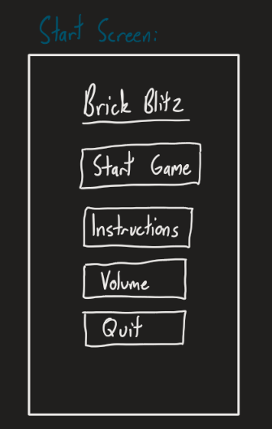

Game Screen:
- Has paddle, ball, bricks

- Scoring system

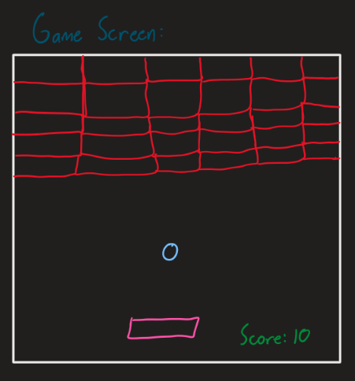

Game Over Screen:
- Has game over message, final score and “Main Menu” button

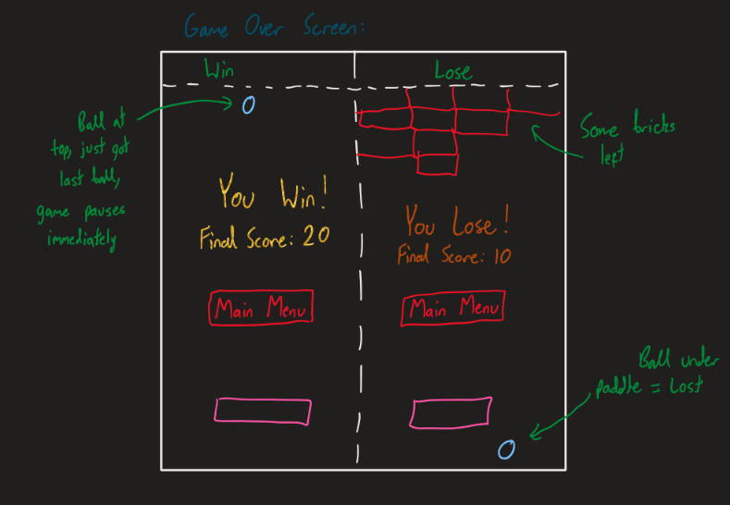

Class Diagram and OOP Principles Used:
Encapsulation:
- Is bundling data and methods that operate on that data into a single unit (A class)

- My classes: Ball, Paddle, Brick, PowerUp, GameObject, all encapsulate their own data (E.g. speed_x, speed_y, x, y), and methods (E.g. move, draw)

Inheritance:
- Allows class to inherit attributes and methods from another class

- Currently, I have a ‘GameObject’ base class, which encapsulates common properties such as ‘x’, ‘y’ and methods such as ‘draw’, ‘move’

- Then the child classes ‘Ball’, ‘Paddle’, ‘Brick’, ‘PowerUp’ all inherit from the parent class ‘GameObject’

  - Allows them to reuse the methods and attributes that GameObject holds, while still adding their own specific behaviour

Polymorphism:
- Allows objects of different classes to be treated as objects of a common superclass. Methods behave differently based on the object that calls them

- Game uses method overriding, where the child classes override the ‘draw’ and ‘move’ methods from the ‘GameObject’ parent class, to provide its own implementation

  - Despite different implementations, all child classes can be treated as ‘GameObject’ instances, so you can call ‘draw’ or ‘move’ on any ‘GameObject’ without knowing the specific type

Abstraction:
- Involves hiding complex implementation details, exposing only the necessary features of an object. Simplifies interaction with objects, by providing clear and simple interface.

- Currently, the plan is to have the ‘GameObject’ class define abstract methods like ‘draw’ and ‘move’ without providing an implementation, forcing the child classes to implement the methods

UML Class Diagram:
